**Capstone Project on**

**University Success Analysis.**

BY

Jeevitha G.

**Project Overview:**

The project aims to design an advanced Power BI dashboard that integrates data from diverse university ranking systems to provide in-depth insights into global higher education. It focuses on analyzing university demographics, ranking methodologies, historical trends, and performance indicators to support informed decision-making and a deeper understanding of ranking dynamics.

Key features of the Power BI dashboard include:

* Analysis of University Demographics and Distribution
* Evaluation of Ranking Systems
* University Metrics and Performance
* Trends and Patterns in Education

The dashboard will enable users to explore relationships between ranking parameters, demographic trends, and university performance. It will also generate practical recommendations for universities to improve their rankings, attract international students, and utilize their resources efficiently.

An essential part of the project involves Exploratory Data Analysis (EDA) using SQL queries to extract and analyze the dataset. This phase will uncover crucial insights, track changes over time, and reveal correlations among variables. The findings will be visualized through graphs, charts, and tables in an Excel file for clear and concise communication of results.

Overall, this initiative is designed to equip stakeholders in the education sector with actionable insights to enhance university rankings, improve institutional appeal, and foster continuous growth in global higher education.

**Comprehensive University Success Analysis: Key Processes and Methodologies**

The **University Success Analysis Project** involves multiple structured phases, each designed to ensure a **systematic and insightful exploration of university rankings, demographics, and performance metrics**. Below is an in-depth breakdown of the methodologies employed at each stage.

**1) Data Acquisition from GitHub**

The first and foremost step in the project is the **acquisition of data** from a designated **university repository on GitHub**. This stage is pivotal in ensuring that **all relevant data points** required for university success analysis are collected efficiently.

Key activities in this phase include:

* **Identifying and accessing the data repository**: Locating the correct GitHub repository that hosts the university-related datasets, ensuring it is publicly accessible or obtaining necessary permissions for private repositories.
* **Gathering comprehensive data**: Extracting multiple datasets that encompass **university rankings across different ranking systems, demographic data, and university performance indicators**.
* **Ensuring compatibility with analysis tools**: Before further processing, the dataset’s format is verified for seamless integration with **SQL-based queries for database exploration** and **Power BI for advanced data visualization**.
* **Downloading the data in appropriate formats**: Structured formats like **CSV, JSON, or Excel** are preferred to maintain data consistency and facilitate a smooth analytical workflow.

This structured approach to data acquisition sets the foundation for **accurate, insightful, and scalable university success analysis**.

**2) Data Transformation**

Once the raw data is acquired, it undergoes a structured **data transformation** process to make it suitable for analysis. This phase ensures that the dataset is **organized, structured, and formatted appropriately** for deriving meaningful insights.

Key transformation techniques include:

* **Data Filtering**: Selecting only relevant rows and columns from the dataset to focus on the most significant variables.
* **Data Aggregation**: Grouping and summarizing data to provide higher-level insights.
* **Data Joining**: Merging multiple datasets using **common keys** such as university IDs to integrate information from different sources.
* **Data Splitting**: Dividing large datasets into smaller subsets based on specific criteria (e.g., **segregating data by country or ranking system**).
* **Reshaping Data**: Modifying the dataset structure through **pivoting or melting**, ensuring it aligns with the analytical objectives.
* **Encoding Categorical Variables**: Converting text-based categorical data into numerical values for computational efficiency.
* **Scaling Numerical Values**: Standardizing numerical data to maintain consistency across different metrics.
* **Feature Engineering**: Creating new variables that capture essential patterns, enabling deeper insights into university success factors.
* **Date Parsing**: Extracting relevant **time-based** information, such as year-wise trends in university rankings.

This stage ensures that the dataset is **well-prepared, structured, and optimized** for subsequent analysis.

**3) Data Cleaning**

Data cleaning is an **indispensable** phase that enhances **data quality, reliability, and accuracy**. This process involves identifying and rectifying anomalies, inconsistencies, and errors in the dataset.

Key steps in data cleaning include:

* **Data Deduplication**: Identifying and removing duplicate records to avoid skewed results.
* **Outlier Handling**: Detecting and mitigating extreme values that could distort findings.
* **Noise Reduction**: Smoothing or filtering **noisy data points** that might introduce errors.
* **Data Type Standardization**: Ensuring consistency in data types (e.g., converting numerical values stored as text into proper numeric formats).
* **Whitespace and Formatting Corrections**: Eliminating **extraneous whitespace, adjusting text case sensitivity, and performing spell checks** to maintain uniformity.
* **Handling Null and Zero Values**: Addressing missing values through **imputation techniques** and managing zero values to avoid misleading analysis.
* **Resolving Inconsistencies**: Standardizing values where inconsistencies exist (e.g., ensuring uniform country names in different datasets).
* **Code Mapping**: Assigning **meaningful labels to coded values** to enhance interpretability.
* **Statistical Validation**: Conducting preliminary **statistical analysis** to assess linearity, distribution, and potential anomalies in the data.

Through meticulous **data cleaning**, the dataset is refined to **eliminate errors and enhance its suitability** for further analytical processes.

**4) MECE Breakdown**

To ensure a **structured and non-overlapping** approach to university success analysis, the project adopts the **MECE (Mutually Exclusive, Collectively Exhaustive) framework**.

This framework categorizes the project into **four distinct phases**, each focusing on a unique aspect of university success:

1. **University Demographics & Distribution**: Analysing the geographic and demographic spread of universities.
2. **University Ranking System Analysis**: Examining different ranking methodologies and their impact.
3. **University Metrics and Performance**: Evaluating various success indicators, such as student outcomes and research output.
4. **Trends and Patterns**: Identifying long-term trends and shifts in university rankings and performance.

This structured approach prevents overlap, ensuring a **clear, logical, and efficient** analysis process.

**5) Connecting with Analytical Tools**

**SQL and Power BI** serve as the primary tools for handling, analysing, and visualizing the data.

* **SQL Integration**:
  + Extracts, manipulates, and queries **structured relational databases** efficiently.
  + Enables **real-time exploration and filtering** of university-related data.
* **Power BI Integration**:
  + Facilitates seamless import and visualization of **CSV data**.
  + Ensures **compatibility, consistency, and transformation capabilities** within Power BI’s environment.
  + Enables dynamic, interactive dashboards for a user-friendly analysis experience.

The integration of these tools **enhances data accessibility and interpretability** across multiple stages of the project.

**Loading CSV Data for SQL**

**CSV Import:**

* + Open your SQL management tool (e.g., SQL Server Management Studio).
  + Use the built-in import wizard to load CSV files into corresponding SQL tables.
  + Ensure that columns match the schema described in the Data Sheets Overview.
  + For example, load the Country.csv, University.csv, etc., into your database to facilitate further SQL queries.

**SQL Queries for KPI Extraction**

* Use SQL queries to extract key metrics such as average ranking scores, student-to-staff ratios, and demographic trends.
* Create views or stored procedures as needed to summarize data for further analysis.

**6) Exploratory Data Analysis (EDA)**

EDA is a **crucial phase** that helps uncover patterns, trends, and relationships within the dataset.

* **SQL-Based Data Exploration**:
  + SQL queries are used to **address specific analytical questions**, such as university ranking distributions and performance comparisons.
  + Data **aggregation, filtering, and transformation** are performed to derive preliminary insights.
* **Excel-Based Visualization**:
  + Graphical representations such as **bar charts, line graphs, and scatter plots** complement SQL findings.
  + Helps **stakeholders visualize key insights in a simplified manner**.

This combination of **SQL for structured analysis and Excel for visualization** provides a **dynamic approach** to exploratory data analysis.

**7) Power BI Analysis & Dashboard Creation**

**Power BI serves as a powerful visualization platform** to translate raw data into meaningful, interactive representations.

* **Visual Techniques Employed**:
  + **Bar/Column Charts** – Comparison of university rankings and distributions.
  + **Pie Charts** – Proportion analysis of universities across different ranking tiers.
  + **Line Charts** – Trend analysis over multiple years.
  + **Matrix Charts** – Complex data representation of university performance.
* **Dashboard Development**:
  + **University Demographics & Distribution Dashboard**
  + **University Ranking System Dashboard**
  + **Performance & Metrics Dashboard**
  + **Trends & Patterns Dashboard**

These dashboards facilitate **data-driven decision-making** for stakeholders, providing **actionable recommendations** based on insights.

**8) Comprehensive Documentation**

Documentation ensures that all **processes, methodologies, and insights** from the project are:

* **Well-organized**
* **Easily accessible**
* **Comprehensible to all stakeholders**.

A detailed **Microsoft Word document** has been created to:

* Capture **data acquisition, transformation, and analysis methodologies**.
* Explain **SQL queries, Power BI dashboards, and visualization techniques**.
* Maintain a structured **record of insights** for future reference.

**Conclusion**

The **University Success Analysis Project** follows a **systematic, structured, and analytical approach**, leveraging **data transformation, SQL-based queries, Power BI dashboards, and statistical methodologies**. This framework ensures an **efficient and insightful exploration of university performance, trends, and success factors**, providing valuable recommendations for decision-makers in the education sector. 🚀

**Objectives of the University Success Analysis Project**

The **University Success Analysis Project** is designed to comprehensively explore, analyze, and interpret university ranking datasets, offering valuable insights for **higher education institutions, policymakers, and stakeholders**. This project leverages **data-driven methodologies, visualization tools, and statistical analysis** to derive meaningful conclusions and actionable recommendations. The following are the key objectives of this project:

### ****1) Data Exploration and Understanding****

The **primary objective** of this project is to conduct a thorough **exploration and comprehension** of the dataset obtained from various **university ranking systems**. This involves:

* **Understanding the structure and attributes** of the dataset, including ranking criteria, demographic distributions, and performance metrics.
* **Identifying relationships and correlations** between different variables, such as **ranking trends, student enrolment rates, and research outputs**.
* **Detecting potential data gaps, inconsistencies, or anomalies** that may impact the accuracy of insights.
* **Establishing a strong foundation** for subsequent analysis by ensuring that all relevant data attributes are well-defined and understood.

By gaining a **holistic understanding of the dataset**, the project ensures that further analysis is **accurate, meaningful, and insightful**.

### ****2) University Demographics and Distribution****

This objective focuses on **segmentation and profiling of universities** based on key demographic and geographic factors. Key goals include:

* **Categorizing universities by country, region, and academic specializations** to identify patterns in institutional distribution.
* **Analysing international student enrolment trends** to assess the impact of **location and ranking on global mobility**.
* **Understanding faculty and student demographics** to highlight diversity and inclusivity in universities worldwide.
* **Developing comprehensive university profiles** to assist institutions in formulating **strategic plans for ranking improvement and student outreach**.

This analysis will help universities **tailor their strategies** to enhance **international visibility, attract global talent, and improve their overall rankings**.

### ****3) University Ranking System Analysis****

With multiple ranking systems available, understanding their differences and impacts is **crucial for universities**. This project seeks to:

* **Examine various university ranking methodologies**, such as **QS World University Rankings, Times Higher Education (THE), and Academic Ranking of World Universities (ARWU)**.
* **Compare ranking criteria across different systems**, evaluating the relative importance of **teaching quality, research output, international collaboration, employer reputation, and citations per faculty**.
* **Analyse how weightage variations influence ranking outcomes**, determining **whether specific criteria disproportionately affect rankings**.
* **Investigate ranking trends over time**, identifying **fluctuations in university positions and their underlying causes**.
* **Assess how ranking methodologies influence international student enrolment and institutional reputation**.

By providing **in-depth insights into ranking mechanisms**, this analysis will enable universities to **develop data-driven strategies to enhance their rankings and global reputation**.

### ****4) University Metrics and Performance Analysis****

This objective aims to **evaluate key performance indicators** (KPIs) that contribute to a university’s success. The analysis will focus on:

* **Assessing year-over-year changes in university rankings** to track institutional performance trends.
* **Examining score distributions across universities** to identify **patterns of high-performing and struggling institutions**.
* **Identifying correlations between ranking factors and success metrics**, such as **research funding, student satisfaction, and faculty qualifications**.
* **Evaluating the impact of institutional investments on rankings**, such as **improvements in faculty-to-student ratios, infrastructure, and academic programs**.
* **Benchmarking institutions against top-performing universities** to highlight best practices and areas for improvement.

Through this analysis, universities can **leverage key performance insights to strengthen their academic standing and operational efficiency**.

### ****5) Trends and Pattern Identification****

A significant goal of this project is to **uncover long-term trends and emerging patterns** in **university rankings, demographics, and performance metrics**. This involves:

* **Tracking global shifts in higher education rankings** over time to identify major changes in university performance.
* **Analysing regional trends in ranking improvements and declines**, providing insights into **geographic disparities in academic success**.
* **Identifying factors that contribute to ranking volatility**, such as **economic conditions, policy changes, or shifts in research funding**.
* **Detecting emerging university success factors**, including the rise of **online education, interdisciplinary research, and technological advancements in learning**.
* **Forecasting future ranking trends** based on historical data, allowing universities to **proactively strategize for sustained growth and success**.

By recognizing these trends, universities can **stay ahead of the curve, adopt best practices, and drive continuous improvement**.

### ****6) Data Visualization and Storytelling****

An essential component of this project is to **effectively communicate findings** through engaging and intuitive **data visualizations**. Utilizing **Power BI**, this objective focuses on:

* **Creating interactive dashboards and reports** that offer stakeholders a **user-friendly and dynamic data exploration experience**.
* **Designing compelling visualizations**, including:
  + **Bar and column charts** to compare university rankings.
  + **Pie charts** for demographic distributions.
  + **Line graphs** to illustrate ranking trends over time.
  + **Heatmaps** to showcase regional university performance.
  + **Matrix charts** for multi-variable performance analysis.
* **Using storytelling techniques to present insights in a clear, structured, and impactful manner**.
* **Ensuring visual clarity and accessibility**, allowing decision-makers to **quickly interpret key findings and take action**.

With **well-crafted visualizations**, complex data can be transformed into **easily digestible insights** that drive **effective decision-making**.

### ****7) Informed Decision-Making for Stakeholders****

The **overarching objective** of this project is to **empower university administrators, policymakers, and higher education stakeholders** with **data-driven insights** for strategic decision-making. This entails:

* **Providing actionable recommendations** based on ranking analysis and university performance trends.
* **Helping universities develop policies and initiatives** that enhance their **academic reputation, student experience, and research output**.
* **Supporting governments and educational bodies** in making informed decisions on **higher education funding, policies, and international collaborations**.
* **Offering insights to students and faculty** regarding **university selection, career opportunities, and institutional strengths**.
* **Driving continuous improvement in the higher education sector** through **data-backed innovation and transformation**.

By **delivering practical, evidence-based recommendations**, this project aims to **enhance university rankings, foster institutional success, and contribute to the evolution of global higher education**.

## ****Conclusion****

The **University Success Analysis Project** is a **comprehensive, data-driven initiative** that aims to **explore, analyze, and visualize university performance and rankings**. Through structured methodologies and advanced analytical tools, this project provides **valuable insights into university demographics, ranking systems, performance metrics, and long-term trends**.

By leveraging these insights, **universities, policymakers, and stakeholders** can make **strategic, informed decisions** that drive **academic excellence, institutional growth, and global competitiveness** in higher education.

# ****Significance of the University Success Analysis Project****

The **University Success Analysis Project** plays a vital role in reshaping the higher education landscape by leveraging **data-driven insights, advanced analytics, and strategic decision-making**. This project **empowers universities, policymakers, and stakeholders** with the necessary knowledge and tools to enhance institutional performance, improve student experiences, and drive academic excellence. The following key areas highlight its significance:

## ****1) Data-Driven Decision-Making****

In an era where **data analytics drives strategic planning**, this project ensures that **university administrators, policymakers, and educators** make **informed, evidence-based decisions**. The significance of this aspect includes:

* **Understanding ranking dynamics:** By analysing various **ranking methodologies, weightages, and performance criteria**, institutions can identify **key success factors** that influence their global standing.
* **Optimizing university strategies:** Institutions can refine their **admission policies, faculty recruitment, research initiatives, and funding allocation** based on **data-backed insights**.
* **Enhancing international competitiveness:** Universities can **benchmark against top-performing institutions**, **identify gaps**, and **implement targeted improvements** to climb global rankings.
* **Supporting long-term planning:** Predictive analytics can help universities **anticipate industry trends**, prepare for **future challenges**, and **align with global academic advancements**.

By integrating **data-driven methodologies**, universities can **foster growth, improve academic excellence, and solidify their global reputation**.

## ****2) Enhanced Student Experience and Academic Success****

Students are the **heart of any academic institution**, and understanding their **needs, behaviours, and preferences** is crucial for delivering an optimal learning experience. This project contributes to **student-centric strategies** by:

* **Segmenting student populations** based on demographics, academic interests, and career goals, allowing universities to **offer personalized education plans**.
* **Improving course structures and faculty effectiveness** by analysing **student satisfaction scores, dropout rates, and academic performance trends**.
* **Enhancing student support services** by identifying **common challenges faced by students**, such as financial aid accessibility, mental health resources, and internship opportunities.
* **Optimizing campus resources and facilities** by examining student feedback on **housing, libraries, extracurricular activities, and digital learning platforms**.
* **Encouraging student retention and success** by implementing **proactive engagement strategies** based on historical trends and predictive modelling.

By focusing on **data-backed improvements to student engagement, satisfaction, and academic performance**, universities can **foster a thriving and supportive educational environment**.

### ****3) Improved Operational Efficiency and Cost Optimization****

Running a university involves **managing vast resources, budgets, and infrastructure**. This project helps institutions **streamline their operations and reduce costs** by:

* **Identifying inefficiencies** in resource allocation, faculty workload distribution, and administrative processes.
* **Optimizing financial expenditures** by analyzing funding utilization, research grants, and student tuition revenue trends.
* **Enhancing faculty and staff productivity** by understanding key performance indicators (KPIs) such as **student-faculty ratios, research output, and administrative efficiency**.
* **Reducing operational bottlenecks** by pinpointing areas that require process automation, better technology adoption, or structural improvements.
* **Facilitating data-driven budget planning** to allocate resources more effectively and prioritize **critical areas such as research, student welfare, and digital transformation**.

With **better resource management, cost control, and operational efficiency**, universities can **invest more effectively in academic excellence and student success**.

### ****4) Competitive Advantage in the Global Education Market****

With thousands of universities **competing for top talent, research funding, and international recognition**, staying ahead requires **strategic planning**. This project provides a **competitive edge** by:

* **Analyzing global ranking trends** to understand the factors that separate **top-performing institutions from lower-ranked ones**.
* **Identifying key differentiators** that attract **high-quality faculty, researchers, and international students**.
* **Developing tailored marketing and outreach strategies** that highlight a university’s **strengths, research contributions, and unique programs**.
* **Enhancing employer partnerships** by aligning university curricula with **job market demands**, ensuring graduates are equipped with **relevant skills and industry connections**.
* **Benchmarking against peer institutions** to assess areas where a university can **outperform its competitors and improve its global standing**.

Through **data-driven insights and strategic improvements**, universities can **position themselves as leaders in higher education, attract top talent, and enhance their global reputation**.

### ****5) Ensuring Data Quality and Reliability in Higher Education Analytics****

The **foundation of any credible analysis is the quality and accuracy of the underlying data. This project establishes rigorous data validation and quality assurance standards, ensuring:**

* **Accurate data collection and verification, eliminating errors and inconsistencies in ranking metrics, student records, and faculty performance data.**
* **Consistency across different ranking methodologies, reducing discrepancies and enhancing the credibility of insights.**
* **Robust data cleaning and transformation techniques to handle missing values, outliers, and redundant data points.**
* **Reliable statistical modeling and machine learning techniques to enhance predictive analytics and ensure valid conclusions.**
* **Enhanced trust in university rankings and reports, improving transparency and accountability in higher education institutions.**

**By setting high standards for data integrity, this project ensures that universities, policymakers, and stakeholders can confidently rely on its findings for strategic decision-making.**

### ****6) Promoting Transparency and Accountability in Higher Education****

In today’s world, **stakeholders demand transparency in academic rankings, funding distribution, and institutional performance**. This project:

* **Documents all methodologies, analysis processes, and data sources**, ensuring that findings are **verifiable and replicable**.
* **Enhances accountability in university ranking systems**, allowing institutions to understand and **challenge discrepancies in ranking assessments**.
* **Provides clear and open reporting mechanisms**, fostering **trust among students, faculty, and policymakers**.
* **Encourages ethical decision-making**, ensuring that universities **adhere to best practices in research, teaching, and administration**.
* **Supports open data initiatives**, promoting the **free exchange of knowledge and educational insights** across institutions worldwide.

By embracing **transparency and accountability**, this project fosters **a culture of openness, integrity, and ethical leadership** in higher education.

### ****7) Knowledge Dissemination and Educational Resource Development****

Beyond institutional improvements, this project serves as a **valuable educational tool** for:

* **Training university staff, administrators, and policymakers** on the importance of **data analysis in strategic planning**.
* **Providing research insights** that can be utilized in academic studies, publications, and conference discussions.
* **Educating students and faculty** on **data literacy, ranking methodologies, and institutional benchmarking**.
* **Collaborating with government agencies and academic organizations** to improve **higher education policies and funding allocation**.

By facilitating **knowledge-sharing and educational advancements**, this project contributes to the **broader academic community and policy-making ecosystem**.

### ****8) Empowering Stakeholders for Continuous Improvement and Innovation****

The ultimate goal of this project is to **empower stakeholders with actionable insights** that drive **sustainable improvements in university performance**. This includes:

* **University Administrators & Leaders** – Helping them design **better policies, research initiatives, and student engagement programs**.
* **Faculty & Researchers** – Enabling them to **understand ranking criteria, optimize teaching methods, and enhance research output**.
* **Students & Prospective Applicants** – Providing valuable insights into **university rankings, career prospects, and academic excellence**.
* **Government & Policymakers** – Assisting in **higher education reforms, funding distribution, and strategic planning**.

By equipping stakeholders with **data-driven knowledge and analytical tools**, this project acts as **a catalyst for innovation, institutional growth, and continuous academic excellence**.

## ****Conclusion****

The **University Success Analysis Project** is a **transformative initiative** that leverages **data analytics, visualization, and predictive modeling** to **enhance university performance, student experiences, and operational efficiency**. Through **evidence-based decision-making, competitive benchmarking, and transparency**, this project **empowers universities and policymakers to shape the future of higher education on a global scale**.

# ****Data Dictionary: University Ranking Dataset****

This dataset encompasses comprehensive information on **global university rankings**, covering various ranking systems, ranking criteria, and university-specific attributes. The dataset consists of **six interrelated tables**, each offering valuable insights into higher education institutions and their performance.

## ****1) Country Table****

## This table provides geographic context by listing the **countries** included in the dataset.

## ID Unique identifier assigned to each country.

## Country_name Name of the country.

## ****2) University Table****

This table contains information about **universities** featured in the ranking systems, with each institution linked to a specific country.

* **ID** Unique identifier for each university.
* **Country ID** Identifier of the country to which the university belongs (linked to the Country Table).
* **University_name** Name of the university

## ****3) Ranking System Table****

This table details the **three ranking systems** used in the dataset, each employing distinct methodologies and criteria.

* **ID** – Unique identifier for each ranking system.
* **System Name** – Name of each ranking system.

## ****4) Ranking Criteria Table****

This table defines the **various ranking criteria** used by each ranking system, including factors such as research impact, faculty quality, and citations.

* **ID** – Unique identifier for each ranking criterion.
* **Ranking System ID** –Identifier of the ranking system (linked to the Ranking System Table).
* **Criteria Name** – Name of each ranking criterion (e.g., citations, teaching quality, research output).

## ****5) University Year Table****

This table tracks **university-specific metrics over multiple years**, capturing demographic and institutional data.

* **University ID** – Unique identifier of the university (linked to the University Table).
* **Year** – Year of observation.
* **Num Students** – Total number of students enrolled at the university.
* **Student-Staff Ratio** – Ratio of students to academic staff at the university.
* **Pct International Students** – Percentage of international students at the university.
* **Pct Female Students** – Percentage of female students at the university.

## ****6) University Ranking Table****

This **core table** contains **ranking scores** for each university, evaluated across different years and ranking criteria.

* **University ID** – Unique identifier of the university (linked to the University Table).
* **Ranking Criteria ID** – Identifier of the ranking criterion (linked to the Ranking Criteria Table).
* **Year** – Year of assessment.
* **Score** – Score assigned to the university based on the ranking criterion.

## ****Relationships Between Tables: University Ranking Dataset****

The dataset is structured as a **relational database**, where key relationships exist between tables:

* **Country Table → University Table** (One-to-Many): Each country has multiple universities.
* **University Table → University Year Table** (One-to-Many): Each university has yearly demographic and student-related data.
* **Ranking System Table → Ranking Criteria Table** (One-to-Many): Each ranking system has multiple criteria.
* **Ranking Criteria Table → University Ranking Table** (One-to-Many): Each ranking criterion is used to assess universities.
* **University Table → University Ranking Table** (One-to-Many): Each university is ranked based on different criteria.

This **structured data model** ensures efficient data exploration, making it easier to analyze **global university performance, ranking trends, and institutional demographics**.

**Entity Relationship (ER) Diagram:**

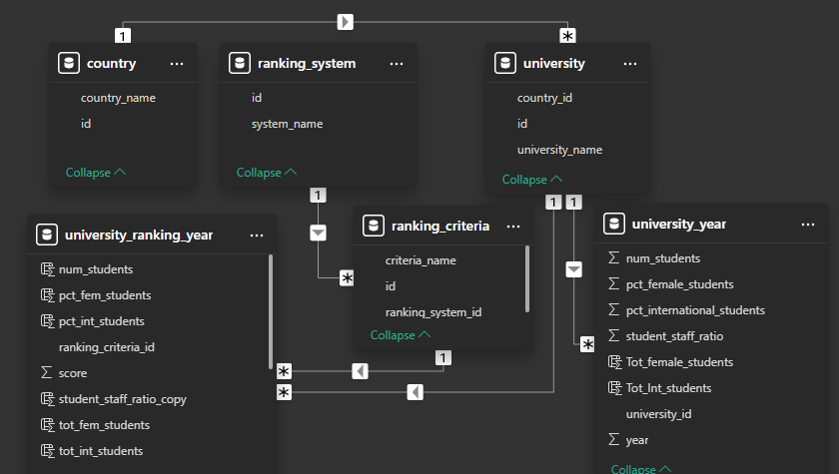

# ****MECE Breakdown for University Success Analysis****

## ****Country-Level Insights****

* Analysis of the number of universities present in each country.
* Examination of how international students are distributed across different nations.
* Assessment of the male-to-female student distribution across various countries.
* Identification of the country with the highest enrolment of female students in universities.
* Evaluation of how universities are geographically dispersed within each country.
* Comparative analysis of university rankings across different countries.

## ****University-Level Insights****

* Determination of the total number of universities ranked by each ranking system.
* Evaluation of university scores as assigned by different ranking systems.
* Analysis of historical trends in university rankings over the years for each ranking system.
* Assessment of the influence of ranking systems on international student enrolment at universities.
* Investigation of the correlation between university rankings and student-to-staff ratios.
* Analysis of the relationship between a university’s ranking score and the percentage of female students.
* Examination of how university ranking scores and student-staff ratios have evolved over time.

## ****Ranking System Insights****

* Identification of the most significant criteria considered by university ranking systems.
* Examination of how universities are distributed among different ranking systems.
* Analysis of university scores in relation to student-to-staff ratios for each ranking system.
* Evaluation of the distribution of international, male, and female students across ranking systems.
* Investigation into the impact of female student enrolment percentages on university rankings.

## ****Trend Analysis****

* Identification of trends in the number of universities over the years.
* Examination of changes in university student-to-staff ratios over time.
* Analysis of trends in male, female, and total student enrolments across different years.
* Observation of fluctuations in university ranking scores over time.
* Investigation of the relationship between university ranking scores and student-to-staff ratios over the years.

# ****Exploratory Data Analysis:****

**Problem Statement: 1**

**Is there a correlation between a country's GDP and the number of universities?**

**SQL Query :**

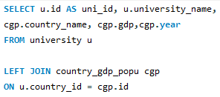

**INSIGHTS:**

The Pearson correlation coefficient between GDP and the number of universities is **0.954**, indicating a very strong positive correlation.

**Higher GDP, More Universities:** Countries with higher GDP tend to have a larger number of universities. This makes sense as wealthier nations invest more in education and research institutions.

**Education as an Economic Driver:** The strong correlation suggests that a country's economic strength supports a robust higher education sector.

**Outliers Exist:** Some countries (like the U.S. and China) have significantly more universities compared to others with similar GDP levels, indicating differences in education policies and priorities.

**Problem Statement: 2**

**How has the number of universities changed over the years in each country?**

**SQL Query & Line Chart :**

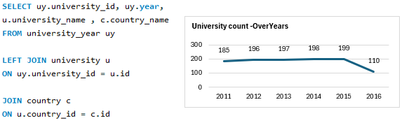

**INSIGHTS:**

The total number of ranked universities increased steadily from **185 in 2011 to 199 in 2015**, indicating growth in higher education institutions meeting ranking criteria. However, in **2016, the number dropped significantly to 110**, suggesting a possible change in ranking methodology.

**United States:** Dominates the rankings with a total of **404 universities** over the years, with its highest count in **2015 (77)** before a sharp decline to **36 in 2016**.

**United Kingdom:** The second-highest contributor, maintaining a steady presence (~27-30 universities per year).

**Germany, Netherlands, Canada, and Australia:** These countries consistently rank within the **top 10**, showing stable higher education systems.

**China and South Korea** have fewer ranked universities than expected given their strong educational investments.

**Turkey shows growth** in later years, jumping from 1 to 4 ranked universities in **2015**, indicating improving education standards.

**Stable Countries:** The **UK, Germany, and the Netherlands** maintained relatively stable numbers over the years.

**Fluctuating Countries:** The **United States, China, and Turkey** showed variations, indicating shifts in university performance or ranking methodologies.

Countries like the **United States, UK, and Germany remain dominant**, while **China, Turkey, and South Korea** show potential for growth.

**Problem Statement: 3**

**Is there a relationship between a country's population and the number of universities?**

**SQL Query & Scatter Plot :**

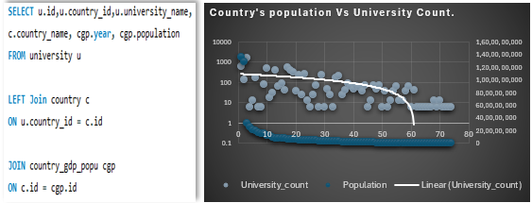

**INSIGHTS:**

There is a weak positive correlation; countries with larger populations tend to have more universities, but it's not a strict linear relationship.

**Outliers:**

* The **United States** has a very high number of universities relative to its population.
* **China** and **India**, despite their huge populations, have fewer universities compared to the U.S.

**Small Populations:** Many small-population countries cluster at the bottom left with only a handful of universities.

**Europe & Developed Nations:** Some countries with moderate populations (e.g., **Germany, UK, France**) have a disproportionately high number of universities.

**Problem Statement: 4**

**Are there any common criteria used by different ranking systems?**

**SQL Query & BarChart :**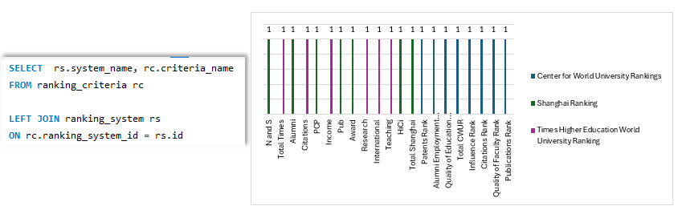

**INSIGHTS:**

Each ranking system applies distinct evaluation criteria.

While some criteria seem thematically similar (e.g., Citations and Publications), they are not explicitly shared across multiple ranking systems.

This confirms that **no two ranking systems use the exact same criteria**, making each system unique in its ranking approach.

**Problem Statement: 5**

**What is the trend in university rankings over the years according to each system?**

**SQL Query & BarChart**

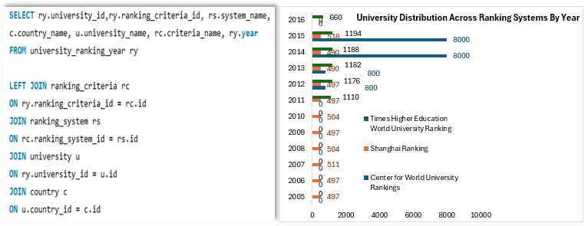

**INSIGHTS:**

CWUR expanded significantly from 2012 to 2015 but has missing data in 2016.

Shanghai Ranking remained consistent with slight variations.

THE Ranking saw an increase until 2015 but dropped in 2016.

#### **1. Center for World University Rankings (CWUR)**

* No recorded data before 2012.
* From **2012 to 2013**, the number remained stable at **800**.
* A **sharp increase** in 2014 and 2015 to **8000**, indicating a significant expansion in the number of universities ranked.
* No data available for 2016.
* **Overall trend:** **Huge expansion** in rankings from 2012 to 2015.

#### **2. Shanghai Ranking**

* **Consistent values (~497-511)** from **2005 to 2011**, suggesting stability.
* A slight dip in 2013 (490) but a **small recovery** in 2015 (518).
* A **drop in 2016 (660)**, possibly due to changes in ranking methodology.
* **Overall trend:** **Stable with minor fluctuations** over time.

#### **3. Times Higher Education (THE) Ranking**

* No data before **2011**.
* A sharp increase from **1110 in 2011** to **1194 in 2015**, indicating that more universities were ranked over time.
* **Drop in 2016 to 660**, suggesting a possible change in ranking criteria or methodology.
* **Overall trend:** **Expansion until 2015, followed by a drop in 2016.**

**Problem Statement: 6**

**How does the choice of ranking system affect a university's international student enrollment?**

**SQL Query:**

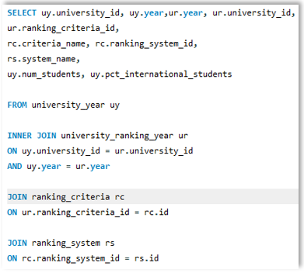**.**

**BAR CHART : International Student Enrolment Vs ranking System:**

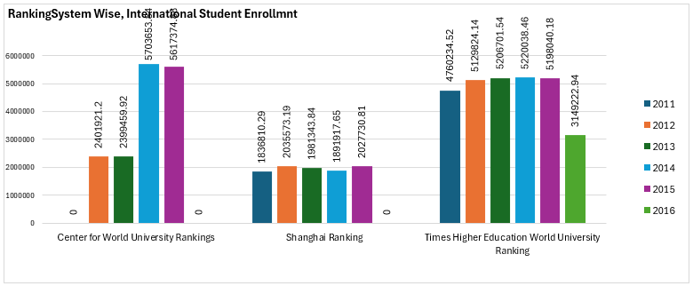

**INSIGHTS :**

**International Student Enrolment Vs ranking System:**

**Times Higher Education (THE) Ranking: Highest values overall, making it the most influential among the three.**

**Drop in 2016 might indicate a change in methodology, which could have influenced student choices.**

**53% of the international student enrolled with the universities that follows 'Times Higher Education World University Ranking' . In 2011, 72% international students enrolled. It was 54% in 2012 & 2013. And 40% in 2014&2015.**

**Centre for World University Rankings (CWUR)** : Shows a **huge jump in values from 2013 to 2014**, suggesting that more universities were ranked or the ranking gained recognition. **30% international students enrolled with universities that follows CWUR.(25% in 2012 &2013 and 44% in 2014 &2015). There is No international students enrolment in 2016.**

**Shanghai Ranking (ARWU)** : **Stable trends with** minor fluctuations over the years, meaning it maintains credibility but doesn’t introduce drastic shifts in university reputations.**18% international students enrolled with universities that follows 'Shanghai Ranking'(In 2011, 28% students enrolled are international Students, it was 21% in 2012 &2013, it was 15% in 2014 &2015) No international students enrolment in 2016.**

**Problem Statement: 7**

**Are there any criteria that have different weights in different ranking systems?**

**SQL Query:**

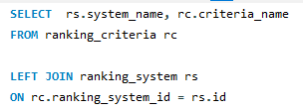

**INSIGHTS :**

**More than one Category don't Follows the same Ranking System.**

**So the criterion has No different weights in different ranking systems.**

**All the ranking System has the same weightage with their respective categories.**

**Problem Statement: 8**

**How have the weights of ranking criteria changed over time?**

**SQL Query:**

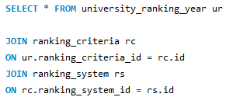

**BAR CHART : Weights Of Ranking Criteria Over Years.**

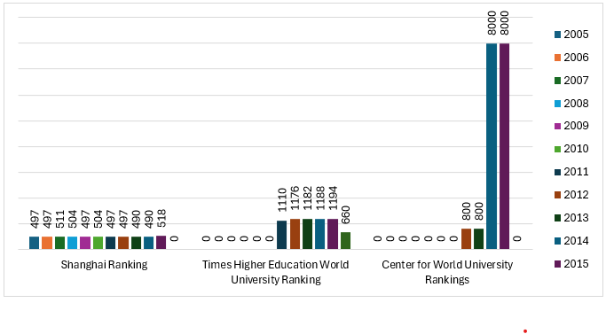

**INSIGHTS :**

**There are 7 Ranking criterias under Shanghai Ranking. All the 7 criterias have been followed by an average of 71 universities from 2005 till 2015 consistently.**

**However, in 2016, these universities didn't follow the Shangai 's ranking criteria.**

**There are 6 Ranking criteria under Times Higher Education WorldUniversity. All 6 criterias have been followed by an average of 180 universities from 2011 to 2016.**

**There are 8 Ranking criteria under Centre for World University Rankings and 100 universities have followed each ranking criteria from 2012 to 2013. There is a sudden spike & 1000 universities have followed each ranking criteria in 2014 & 2015.**

**However, in 2016, none of the universities have followed these ranking criteria.**

**Problem Statement: 9**

**Is there a relationship between a university's score and the student-staff ratio?**

**SQL Query & Scatter Plot:**

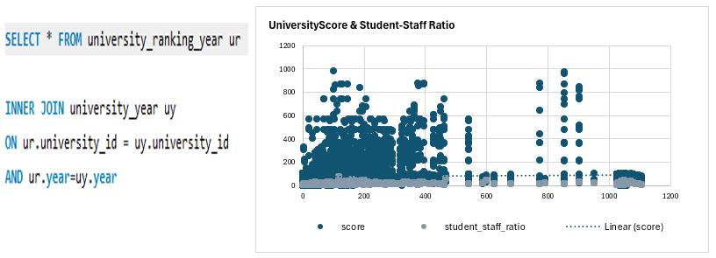

**INSIGHTS :**

**This indicates a very weak positive correlation, meaning that as the student-staff ratio increases, the ranking score slightly increases, but the relationship is not strong.**

**The weak correlation suggests that student-staff ratio alone does not significantly impact ranking score. Other factors likely play a more substantial role.**

**Diverse University Models: Some universities may have a high student-staff ratio but still maintain high ranking scores due to other quality metrics like research output, funding, or reputation.**

**Co-relation coefficient is 0.063**

**Problem Statement: 10**

**How does the number of female students differ among universities?**

**SQL Query :**

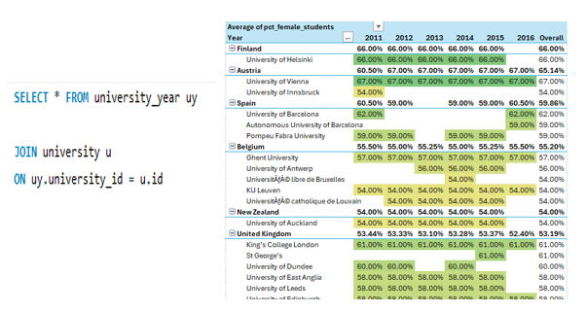

**INSIGHTS:**

**University of Helsinki from Finland (67%) & University of Vienna from Austria(65%) has higher female enrolment than male students.**

**Followed by (3 univ.) Spain, (5 univ. )Belgium, (1 univ.) newsland, (28 univ.) UK has 50% of their students to be Female.**

**However, universities from Japan, s.Korea, Norway has very less female enrolment lower than (30%).**

**Problem Statement: 11**

**What is the distribution of universities across different countries?**

**SQL Query & Pareto Chart:**

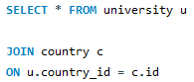

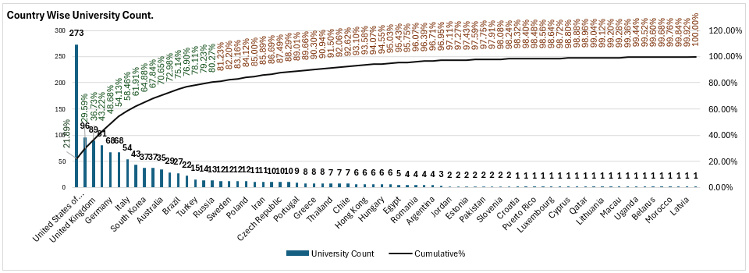

**INSIGHTS:**

**The United States has the highest number of ranked universities (273), significantly ahead of other countries.**

**This accounts for approximately 22% of all ranked universities, showing its strong global academic presence.**

**China (96 universities) follows as the second-highest, showing its growing influence in higher education.**

**The United Kingdom (89), Japan (81), and several European countries (Germany - 68, France - 68, Italy - 54, Spain - 43, Netherlands - 14, Sweden - 12, etc.) also have substantial representation.**

**Countries like India (22 universities), Brazil (27), South Korea (37), and Canada (37) indicate strong academic investments.**

**By the time we reach the top 10 countries, about 68% of all ranked universities are accounted for.**

**The distribution shows that a small number of countries dominate rankings, with the majority of universities concentrated in a few key nations.**

**Problem Statement: 12**

**How has the ranking of universities changed over the years?**

**SQL Query & SparkLine:**

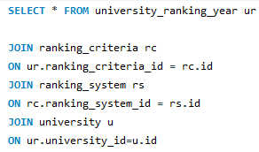

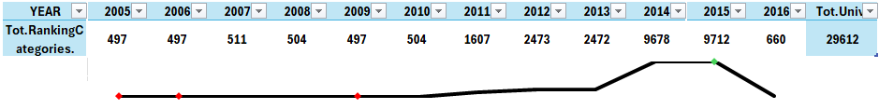

**INSIGHTS:**

**From 2005 to 2010 there was only 1 ranking system(Shanghai Ranking) been followed by 80 Universities from 15 countries.**

**Times Higher Education World University Ranking was followed by 245 universities from 30 countries as of 2011 till 2016.**

**Centre for World University Rankings was followed by 1024 universities from 59 countries as of 2012 till 2015**

**From 2012, All the 3 ranking system has been diversely followed in 1064 universities from 59 countries.**

**Since 2005 till 2016, there are 1065 universities across 59 countries following a ranking system.**

**Problem Statement: 13**

**What is the trend in the percentage of female students over time?**

**SQL Query:**

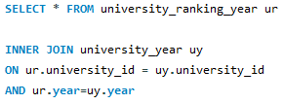

**Line Chart For Female Students % over Years.**

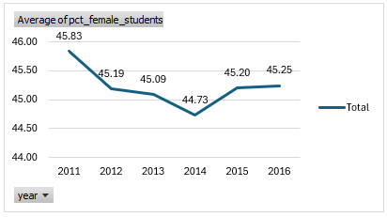

**INSIGHTS:**

**The average percentage hovers around the mid-40s range, indicating a relatively stable female student representation over these six years.**

**There is a small decrease from 45.83% in 2011 to 44.73% in 2014, followed by a gradual rebound to 45.25% in 2016.**

**This fluctuation is minor (within a 1–1.5% range), suggesting no dramatic shifts in female enrollment during the observed period.**

**Problem Statement: 14**

**How has the ranking score of universities evolved over the years?**

**SQL Query:**

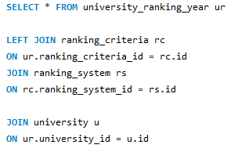

**BAR CHART for Ranking Scores Over Years :**

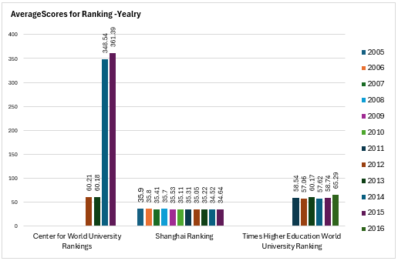

**INSIGHTS:**

**CWUR shows a sharp increase, indicating a growing number of ranked universities or changes in its ranking methodology.  
Shanghai Ranking (ARWU) remains relatively stable, suggesting a consistent evaluation process.  
THE Ranking exhibits fluctuations, possibly due to changes in criteria, methodology, or global academic performance trends.**

#### ****1. Center for World University Rankings (CWUR)****

* CWUR scores are available only from **2011 onward**.
* The scores show a significant increase from **60.21 (2011) to 361.39 (2014)**, indicating growing emphasis on CWUR criteria.
* After 2014, scores show **slight fluctuations**, suggesting stabilization.

#### ****2. Shanghai Ranking (ARWU)****

* The scores remain **relatively stable** over the years, fluctuating around **35.11 to 35.89**.
* A slight downward trend is observed, with **2014 recording one of the lowest scores (34.52)**.
* This consistency suggests that Shanghai Ranking maintains a stable evaluation methodology with minor variations.

#### ****3. Times Higher Education (THE) Ranking****

* Scores are recorded from **2011 onwards**, showing more volatility.
* Starting at **58.54 in 2011**, the score **peaked at 65.29 in 2015** before dropping to **59.14 in 2016**.
* This fluctuation suggests that THE ranking criteria and weightages may have evolved over time.

**Problem Statement: 15**

**Is there a relationship between a university's ranking score and the number of students over time?**

**SQL Query & Scatter Plot For University RankingScore & No. Of Students:**

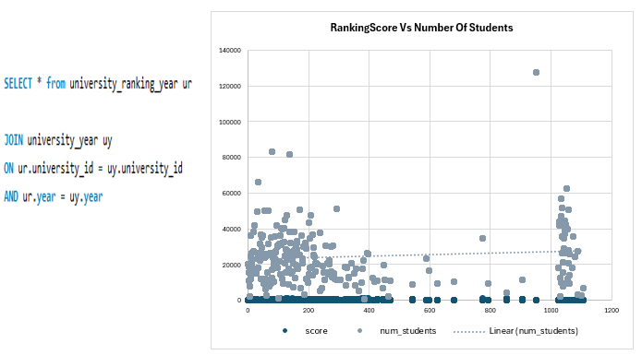

INSIGHTS:

A weak negative correlation (-0.11718) between **ranking score** and **number of students** suggests that **as the number of students increases, the ranking score slightly tends to decrease**—but the effect is minimal.

# ****POWER BI Data Analysis:****

**Problem Statement: 1**

**How many universities are there in each country?**

**VISUALIZATION:**

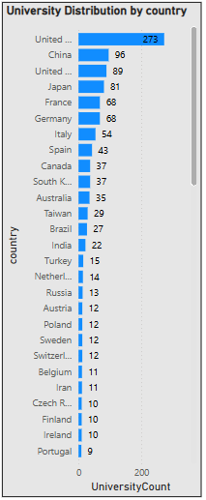

**INSIGHTS:**

**Top Countries** with the Most Ranked Universities :

United States (273 universities) has the highest number of ranked institutions, dominating global rankings.

China (96), United Kingdom (89), and Japan (81) also have a significant presence. France (68) and Germany (68) are among the leading European countries.

**Mid Ranked Countries**

Italy (54), Spain (43), South Korea (37), Canada (37), and Australia (35) have well-established education systems.

**Limited Number Of Universities**

Taiwan (29), Brazil (27), and India (22) also show a growing presence in university rankings. These Countries have fewer universities overall but maintain strong academic institutions.

**Minimal Representation** :

Several countries have only 1–2 ranked universities, including Bangladesh, Kenya, Iceland, Morocco, Qatar, and Uruguay.

**Problem Statement: 2**

**What is the distribution of international students across different countries?**

**VISUALIZATION:**

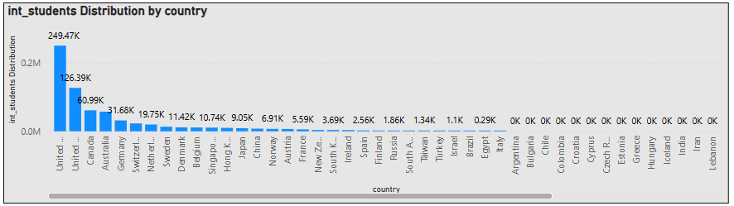

**INSIGHTS:**

**Top Host Countries for International Students :**

**The US (24,968,846 students ) is the leading destination for international students, significantly ahead of other countries.**

**The UK(12,635,743 students) is the second-largest host country, with renowned institutions like Oxford, Cambridge, and Imperial College.**

**Followed by Canada (6,108,748 students) that has Lower tuition fees compared to the US make it a favorable destination.**

**Australia – (5,726,985 students) for its strong education system and post-graduation work opportunities.**

**Germany – (3,174,065 students) Offers tuition-free or low-cost education,**

**Moderate :**

**Switzerland (2,298,820), Netherlands (1,977,496), Sweden (1,345,669), Denmark (1,151,424), Singapore (1,073,928) & Hong Kong (996,500).**

**No Record :**

**Countries like Argentina, India, Saudi Arabia, and Mexico show zero recorded international students in the dataset.**

**Problem Statement: 3**

**Which country has the highest number of female students enrolled in universities?**

**VISUALIZATION:**

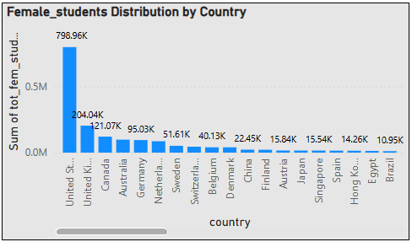

**INSIGHTS:**

**Country with the Highest Female Enrolment:**

**The United States has the highest number of female students enrolled in universities, with approximately 79.89 million female students out of a total 167.25 million students. This means that about 31.16% of all university students in the U.S. are female.**

**Top 5 Countries with the Most Female Students:**

**United Kingdom ranks second with 20.37 million female students out of 38.68 million students, making up 39.44% of the total student population. Canada follows closely with 12.11 million female students, accounting for 31.51% of total enrolments. Australia has about 9.80 million female students, which is 32.73% of its university student population. Meanwhile, Germany has 9.49 million female students, with a lower percentage of 22.32% of total students.**

**Highest Female Proportion :**

**Denmark leads with 50.35% of university students being female, indicating a strong level of gender equality in higher education. The Netherlands follows with 49.03%, while Singapore has 48.54% female student representation. Sweden and Hong Kong also show high levels of female participation, with 42.07% and 40.54%, respectively.**

**Lowest Female Proportions :**

**South Korea (3.57%), China (3.92%), Brazil (4.48%), and Japan (4.68%) also show notably low female student representation,**

**Problem Statement: 3**

**How many universities are ranked by each ranking system?**

**VISUALIZATION:**

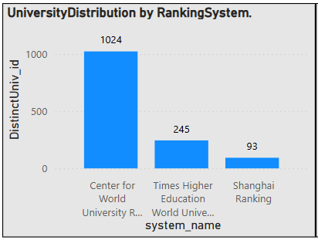

**INSIGHTS:**

**Times Higher Education World University Ranking**

The number of universities ranked varies across years.

The ranking peaked in **2015 (199 universities)** and was lowest in **2011 (185 universities)**.

This suggests that the methodology or the number of institutions considered changed over time.

**Centre for World University Rankings**

Consistently ranks **100 universities** every year.

This suggests a **fixed ranking approach**, where they always rank the same number of institutions.

**Shanghai Ranking**

Mostly ranks **71–74 universities per year**, except for **2014, where it ranked 70**.

This indicates a relatively stable ranking system with minor yearly fluctuations.

**Problem Statement: 4**

**What is the average score for universities according to each ranking system?**

**VISUALIZATION:**

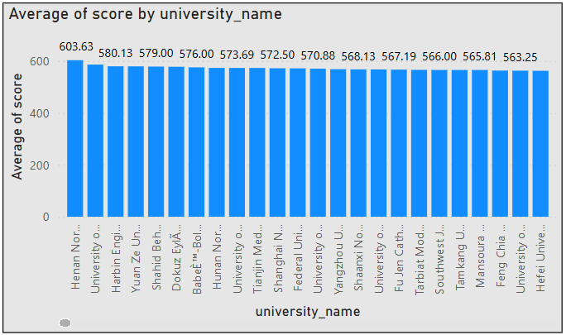

**INSIGHTS:**

**CWUR scores are significantly higher (356.19) than THE (56.88) and Shanghai Ranking (32.90).**

**This suggests that CWUR uses a different scale, possibly scoring universities out of higher numerical values.**

**THE and Shanghai Ranking might use a normalized scale with a lower range.**

**Shanghai Ranking gives the lowest average scores (32.90), indicating a more stringent evaluation process.**

**It is known for emphasizing research output and Nobel Prize winners, which might explain lower scores.**

**THE considers teaching, research, and international outlook, leading to slightly higher scores.**

**Problem Statement: 5**

**How does the ranking system affect a university's student-staff ratio?**

**VISUALIZATION:**

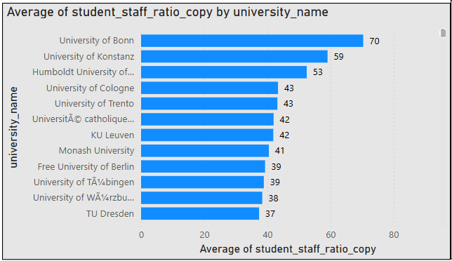

**INSIGHTS:**

**Shanghai Ranking Has the Lowest Student-Staff Ratio (14.74) Universities ranked by Shanghai Ranking tend to have smaller class sizes and more faculty per student. This suggests that Shanghai Ranking may favor research-heavy institutions with better faculty availability.**

**THE and CWUR Have Slightly Higher Ratios (~16.2) Times Higher Education (16.32) and CWUR (16.17) show similar trends. These ranking systems may focus on other academic factors like research output, citations, or employer reputation, rather than just student-faculty interaction.**

**Variation Is Relatively Small (~1.58 Difference Between Highest and Lowest) The difference in student-staff ratio between ranking systems is not drastic (~1.58 points).This indicates that faculty availability does not significantly change across ranking systems. The difference in student-staff ratio between ranking systems is not drastic (~1.58 points).**

**This indicates that faculty availability does not significantly change across ranking systems.**

**Problem Statement: 6**

**What are the most important criteria considered by ranking systems?**

**VISUALIZATION:**

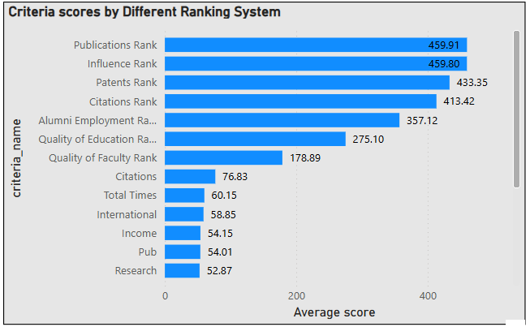

**INSIGHTS:**

**The highest average scores belong to Publications Rank (459.91) and Influence Rank (459.80) in the Center for World University Rankings (CWUR).**

**Citations Rank (413.42) is also highly significant, indicating that universities with more research output and citations are ranked higher.**

**In Times Higher Education, Citations (76.83) has the highest score, further emphasizing the role of research.**

**Shanghai Ranking also prioritizes research with Pub (54.01) and HiCi (Highly Cited Researchers, 36.59).**

**Research output, citations, and publications play the most crucial role in university rankings across different ranking systems.**

**Problem Statement: 7**

**Is there a correlation between a university's score and the number of international students?**

**VISUALIZATION:**

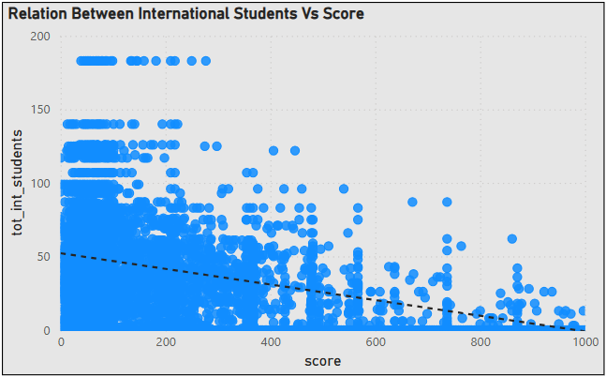

**INSIGHTS:**

**A moderate negative correlation is observed, indicating that an increase in the total number of international students tends to result in a decrease in scores.**

**This relationship remains consistent even in the presence of outliers. From the chart on the left, it can be inferred that ranking criteria associated with higher scores exhibit a moderate negative correlation. Conversely, ranking criteria with lower scores either have fewer international students or show no significant correlation**

**Problem Statement: 8**

**How does the percentage of female students impact a university's ranking?**

**VISUALIZATION:**

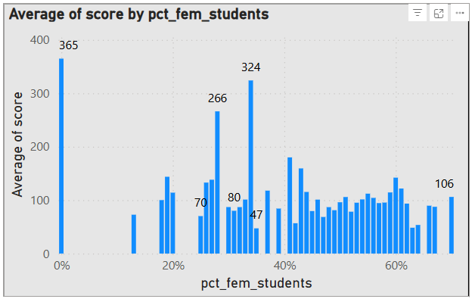

**INSIGHTS:**

**In Ranking System(CWUR), universities with a higher percentage of female students (e.g., 34%, 28%, 27%) tend to have higher ranking scores (479.38, 360.93, 301.41, etc.).**

**In Ranking System (Shanghai & THE Rankings), many universities with low female representation (0%, 19%, 20%) have significantly lower ranking scores (e.g., 61.26, 50.22, 48.5).**

**The lowest scores (e.g., 23.9, 24.61, 26.45) tend to appear when female representation is low.**

**Universities with 30%-50% female students appear throughout the ranking spectrum, meaning they do not disproportionately affect rankings.**

**Problem Statement: 9**

**Which university has the highest number of students?**

**VISUALIZATION:**

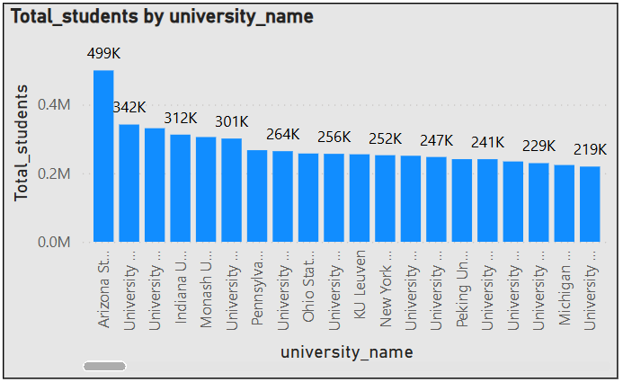

**INSIGHTS:**

**Arizona State University (499,416 students) is the largest university in terms of total student enrolment.**

**University of Massachusetts (341,754 students) and University of Toronto (330,990 students) follow as the second and third largest institutions.**

**The majority of the largest universities are in the United States, Canada, Europe, and Asia.**

**United States dominates the list with many universities having large student enrolments (e.g., Penn State, Ohio State, University of California schools).**

**Canada has significant representation with major institutions like University of Toronto, University of British Columbia, and McGill University.**

**European universities such as KU Leuven, LMU Munich, University of Vienna, and University of Manchester have high student populations.**

**Asian universities like Peking University, Tsinghua University, National University of Singapore, and Seoul National University have substantial enrolments.**

**Problem Statement: 10**

**How does the percentage of international students vary across different universities?**

**VISUALIZATION:**

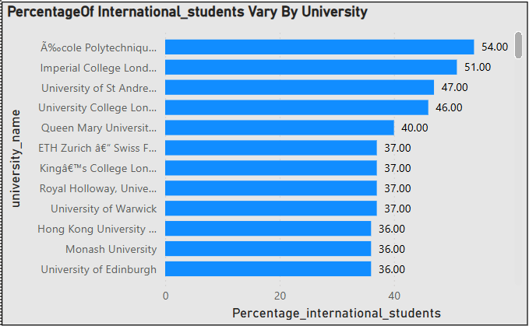

**INSIGHTS:**

**UK and Switzerland Dominate: Many of the top institutions are from the United Kingdom (e.g., UCL, Imperial, St Andrews, Cambridge, Oxford) and Switzerland (EPFL, ETH Zurich).**

**Hong Kong and Singapore Also Rank High: Universities like University of Hong Kong (38%), Hong Kong University of Science and Technology (36%), and National University of Singapore (34%) have strong international appeal.**

**Australia and Canada Have Strong Representation: Australian universities like Monash (36%) and University of Melbourne (35%), along with University of British Columbia. (25%) and McGill University, (23%), also attract large numbers of international students.**

**European universities, particularly in Switzerland, the UK, and the Netherlands, have the highest**

**International student ratios.**

**The U.S. has a mix of highly international universities (MIT, Columbia) and more domestically focused**

**Institutions (Wisconsin, Texas, Florida).**

**Asian universities (Tsinghua, Peking, Tokyo) have lower international enrolment compared to**

**Western counter parts.**

**Problem Statement: 11**

**Is there a correlation between a university's ranking and its student-staff ratio?**

**VISUALIZATION:**

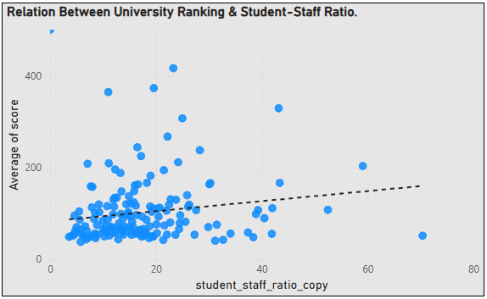

**INSIGHTS:**

**This indicates a weak positive correlation between the student-staff ratio and the university score.**

**The weak correlation suggests that student-staff ratio is not a strong determinant of university ranking.**

**Higher-ranked universities do not necessarily have lower student-staff ratios. Some top institutions might still have high ratios but compensate in other ways.**

**Problem Statement: 12**

**How does the number of students in universities change over time?**

**VISUALIZATION:**

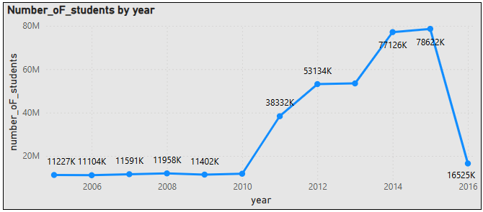

**INSIGHTS:**

**US :The number of students peaked in 2015 (29.3 million) but showed a decline afterward.**

**UK: Student numbers peaked in 2014 (8.07 million) and slightly declined in 2015.**

**Canada : Consistent growth from 2005 (~1.2 million) to 2015 (~5.98 million). Suggests increasing demand for education or higher international student intake.**

**Germany: Gradual increase from 2011 (~2.48 million) to 2015 (~5.35 million).**

**China: Lower student counts compared to the U.S. but a steady rise from 2011 (~1.25 million) to 2015 (~2.71 million).**

**Australia & Netherlands: Australia showed steady growth, reaching 3.63 million in 2015. The Netherlands followed a similar trend but at lower numbers (~3.6 million in 2015).**

**Japan, South Korea, and Hong Kong showed stable but stagnant or slightly declining numbers.**

**Problem Statement: 13**

**Is there a correlation between a university's ranking score and the student-staff ratio over the years?**

**VISUALIZATION:**

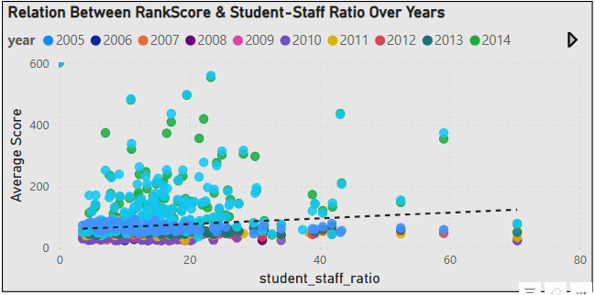

**INSIGHTS:**

**This indicates a very weak positive correlation, meaning that as the student-staff ratio increases, the ranking score slightly increases, but the relationship is not strong.**

**The weak correlation suggests that student-staff ratio alone does not significantly impact ranking score. Other factors likely play a more substantial role.**

**Diverse University Models: Some universities may have a high student-staff ratio but still maintain high ranking scores due to other quality metrics like research output, funding, or reputation.**

**Problem Statement: 14**

**How does the percentage of international students vary across different years?**

**VISUALIZATION:**

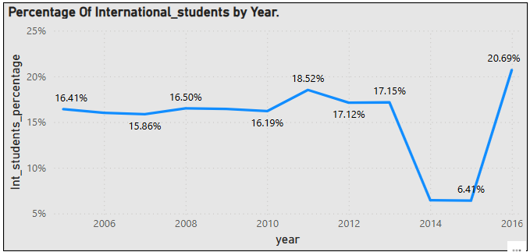

**INSIGHTS:**

**The peak percentage of international students was in 2016 (21%), indicating a strong attraction of international students to universities during that time.**

**The percentage hovered between 16% to 19% from 2005 to 2013, showing relative stability.**

**The slight increase in 2011 (19%) and 2013 (17%) might suggest a period of growth in international student enrolment.**

**A sharp decline to 6% in 2014 and 2015 suggests major disruptions.**

**After the 2014-2015 dip, the percentage jumped back up to 21% in 2016.**

**The percentage of international students was relatively stable (16%-19%) from 2005 to 2013.**

**A sharp decline in 2014-2015 (6%) signals a major disruption.**

**A strong recovery in 2016 (21%) suggests a bounce-back in international student interest.**

**Problem Statement: 15**

**What is the impact of a university's ranking on the number of international students it attracts?**

**VISUALIZATION:**

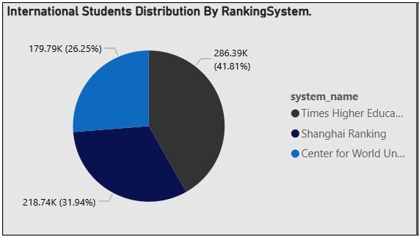

**INSIGHTS:**

**Centre For World University Ranking :**

**The number of international students was relatively low in 2012 (24,032) and 2013 (24,864). In 2014 and 2015, it jumped significantly to 65,448, indicating a major increase.**

**Shanghai Ranking :The number of international students remained fairly stable from 2005 to 2015, fluctuating around 19,000 to 20,500.A slight drop in 2014 (18,900) was followed by a recovery in 2015 (20,265). There was a steady increase from 2011 (47,556) to 2015 (51,924), suggesting a growing attractiveness.**

**Times Higher Education :**

**There was a steady increase from 2011 (47,556) to 2015 (51,924), suggesting a growing attractiveness. However, in 2016, the number dropped significantly to 31,452, which could indicate a decline in ranking, stricter immigration policies, or financial constraints for international students.**

**Problem Statement: 16**

**Is there a relationship between a university's ranking score and the percentage of female students enrolled?**

**VISUALIZATION:**

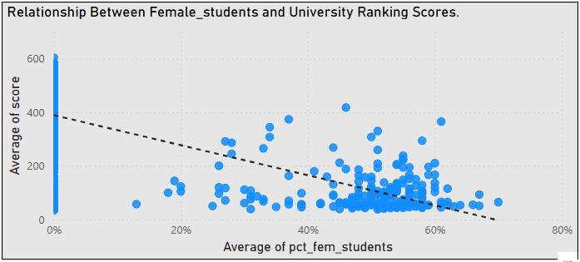

**INSIGHTS:**

**The correlation coefficient between the university ranking score and the percentage of female students enrolled suggests a moderately strong negative relationship: as the percentage of female students increases, the ranking score tends to decrease.**

**Problem Statement: 17**

**How does the percentage of international students affect a university's student-staff ratio?**

**VISUALIZATION:**

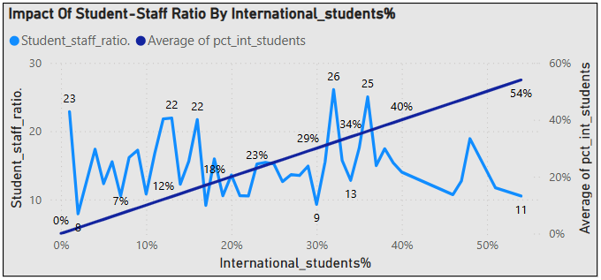

**INSIGHTS:**

**Universities with higher international student percentages (e.g., 51%, 54%) tend to have a lower student-staff ratio (e.g., 11.7, 10.5).**

**Universities with a lower percentage of international students (e.g., 1%, 13%) exhibit a higher student-staff ratio (e.g., 22.86, 21.91).**

**Some universities with moderate international student percentages (e.g., 32%, 36%) still have a high student-staff ratio (e.g., 26.1, 25.01). The data shows an inverse correlation between the percentage of international students and the student-staff ratio in many cases. However, exceptions exist where high international student enrolment does not necessarily translate into a lower student-staff ratio.**

**Problem Statement: 18**

**Are there any significant trends or patterns in the rankings of universities from different countries?**

**VISUALIZATION:**

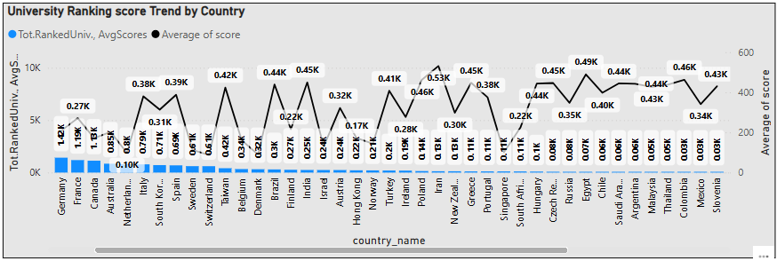

**INSIGHTS:**

**The United States has the highest number of universities in the dataset (9,969), followed by the United Kingdom (2,621) and Japan (1,700).**

**Countries like China (413.83), Brazil (439.13), India (449.51), and Iran (531.2) have higher average scores, suggesting that many of their universities are ranked lower in global standings.**

**In contrast, Switzerland (87.46), the Netherlands (97.94), and Singapore (101.39) have much lower average scores, indicating that their universities tend to be ranked higher.**

**Western European countries such as Germany (209.26), France (271.3), and Italy (380.02) have a mix of high- and lower-ranked universities, while smaller countries like Switzerland (87.46) and the Netherlands (97.94) have institutions that generally perform well.**

**Countries like Iran (531.2), Romania (535.46), and Uganda (519.13) have high average scores, suggesting that their universities are less competitive globally.**

**POWER BI DASHBOARDS:**

**COUNTRY ANALYSIS**

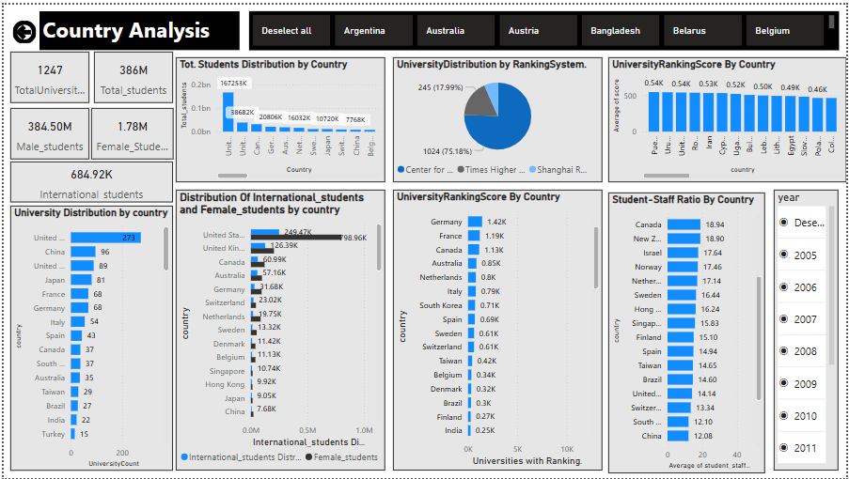

**UNIVERSITY ANALYSIS**

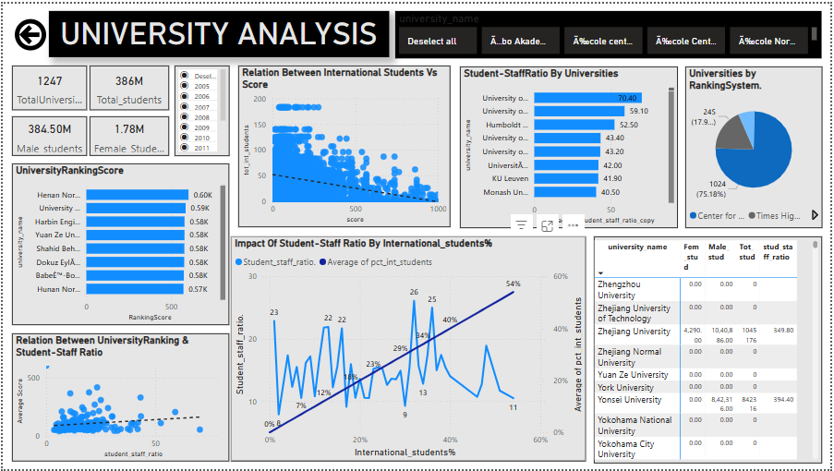

**RANKING ANALYSIS**

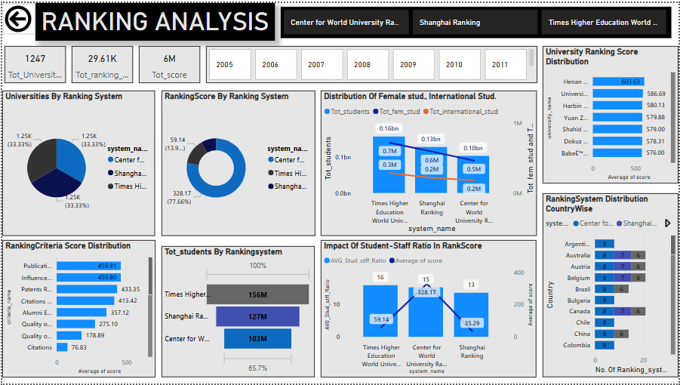

**YEAR ANALYSIS:**

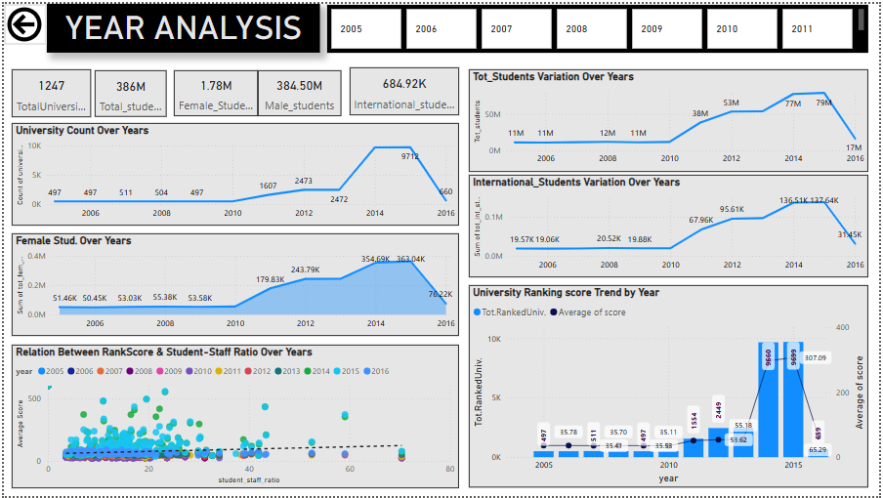

# ****CONCLUSION:****

**This in-depth analysis of university rankings, demographics, and global trends has offered profound insights into the ever-evolving higher education sector. By employing tools like Power BI, SQL, and Excel, I have thoroughly explored the complexities of academic performance, institutional attributes, and the dynamic frameworks of ranking systems.**

**The investigation revealed significant findings, such as the unequal distribution of universities across nations and the relationship between student populations and institutional counts. I identified how ranking criteria influence university scores and examined the connections between ranking systems and the enrolment patterns of male, female, and international students. A notable insight was the significant concentration of universities in the United States, emphasizing its central role in global higher education. Furthermore, the diverse methodologies and unique evaluation criteria used by ranking systems highlighted the challenges of globally benchmarking academic institutions.**

**The study also uncovered shifting trends in university rankings over time, including variations in scores, weighting of criteria, and demographic shifts. Additionally, the analysis explored connections between ranking scores, student-to-staff ratios, and the representation of female students, offering key insights for educational stakeholders. Patterns in student demographics were also observed, with notable trends in female and international enrolments, reinforcing the need for inclusive and supportive educational environments.**

**In conclusion, this project underscores the value of data-driven decision-making in shaping effective strategies, policies, and investments within the education sector. By leveraging advanced analytical approaches, this work has provided a richer understanding of the factors influencing university success on a global scale. With these insights, I am ready to continue exploring the dynamic landscape of higher education and apply these perspectives to future initiatives.**